Date: 19/08/2020

**Practical no 1**

**AIM:** Write a program to implement to create a simple web service that converts the temperature from Fahrenheit to Celsius and vice versa.

# **Steps:**

1. Create a Web Application of ”ASP.NET” using(.Net Framework 4.7).
2. Give a suitable title to the project and solution.
3. Initialize it as ”Empty” solution.
4. On Solution Explorer, right click and add a ”Web Service(asmx)” to the solution.
5. Moving ahead we already have the files initialized for returning ”Hello World”.
6. Remove/overwrite the ”Hello World” ”WebMethod” and add your own ”WebMethods” to the source file.
7. Save it and try out the web-service using the play button to host the web service on a local ”IIS Express” server.
8. Once the web service successfully runs and gives the desired output in form of XML documents; We will Proceed towards making client side pages.
9. In solution explorer, right click on the connected services tab and click on ”add service reference” option.
10. Next discover the web service we just created and click on the service you created and click ok.
11. Now you have successfully connected the web service to the solution.
12. Add a new WebForm in the same solution and start designing the client side UI.
13. After completing the UI design open the backend C# code.
14. Define methods for Button Clicks either explicitly or by double clicking the respective buttons in the design section of the form .
15. In the button click methods first create a SOAP object for the ”webservice.WebService1SoapClient()” class.
16. Using the SOAP object invoke the web-service methods and pass the appropriate data from the input field casted to the data type used in web-service method.
17. Next try running the ASPX page using the local server, add exception handling for handling exceptions if required.

**Code:**

**WebService1.asmx.cs**

|  |
| --- |
| using System;  using System.Collections.Generic;  using System.Linq;  using System.Web;  using System.Web.Services;  namespace Temp  {    [WebService(Namespace = "http://tempuri.org/")]  [WebServiceBinding(ConformsTo = WsiProfiles.BasicProfile1_1)]  [System.ComponentModel.ToolboxItem(false)]    public class WebService1 : System.Web.Services.WebService  {  [WebMethod]  public double celsius_to_farhenheit(double celsius)  {  return ((celsius * 9 / 5) + 32);  }  [WebMethod]  public double farhenheit_to_celsius(double farhenheit)  {  return ((farhenheit - 32) * 5 / 9);  }  }  } |

**WebForm1.aspx:**

|  |
| --- |
| <%@ Page Language="C#" AutoEventWireup="true" CodeBehind="WebForm1.aspx.cs" Inherits="Temp.WebForm1" %>  <!DOCTYPE html>  <html xmlns="http://www.w3.org/1999/xhtml">  <head runat="server">  <title></title>  </head>  <body>  <form id="form1" runat="server">  <div>  <asp:Label ID="Label1" runat="server" Text="Input Temperature"></asp:Label>  &nbsp;&nbsp;    <asp:TextBox ID="TextBox1" runat="server"></asp:TextBox>&deg;  <asp:DropDownList ID="DropDownList1" runat="server">    <asp:ListItem>Celsius</asp:ListItem>  <asp:ListItem>Farhenheit</asp:ListItem>    </asp:DropDownList>    <br/><br/>  <asp:Button ID="Button1" runat="server" Text="Convert_to_Farhenhiet" OnClick="Button1_Click"/>  &nbsp;&nbsp;&nbsp;&nbsp;  <asp:Button ID="Button2" runat="server" Text="Convert_to_Celsius" OnClick="Button2_Click" />  <br/><br/>  <asp:Label ID="Label3" runat="server" Text="Result :"></asp:Label>  &nbsp;  <asp:Label ID="Label2" runat="server" Text=""></asp:Label>  &nbsp;<asp:Label ID="Label4" runat="server" Text=""></asp:Label>  </div>  </form>  </body>  </html> |

**WebForm1.aspx.cs**

|  |
| --- |
| using System;  using System.Collections.Generic;  using System.Linq;  using System.Web;  using System.Web.UI;  using System.Web.UI.WebControls;  namespace Temp  {  public partial class WebForm1 : System.Web.UI.Page  {  protected void Page_Load(object sender, EventArgs e)  {  }  protected void Button1_Click(object sender, EventArgs e)  {  double result;  try  {  ServiceReference1.WebService1SoapClient client = new ServiceReference1.WebService1SoapClient();  result = client.celsius_to_farhenheit(Convert.ToDouble(TextBox1.Text));  if (DropDownList1.SelectedValue.Equals("Celsius"))  {  Label2.Text = result.ToString();  Label4.Text = "&deg;Farhenheit";  }  if (DropDownList1.SelectedValue.Equals("Farhenheit"))  {  Label2.Text = "Already in Farhenheit";  Label4.Text = "";  }  }  catch (System.FormatException)  {  Label2.Text = "Invalid Inputs";  Label4.Text = "";  }  }  protected void Button2_Click(object sender, EventArgs e)  {  double result;  try  {  ServiceReference1.WebService1SoapClient client = new ServiceReference1.WebService1SoapClient();  result = client.farhenheit_to_celsius((Convert.ToDouble(TextBox1.Text)));  if (DropDownList1.SelectedValue.Equals("Celsius"))  {  Label2.Text = "Already in Celsius";  Label4.Text = "";  }  if (DropDownList1.SelectedValue.Equals("Farhenheit"))  {  Label2.Text = result.ToString();  Label4.Text = "&deg;celsius";  }  }  catch (System.FormatException)  {  Label2.Text = "Invalid Inputs";  Label4.Text = "";  }  }  }  } |

**Outputs:**

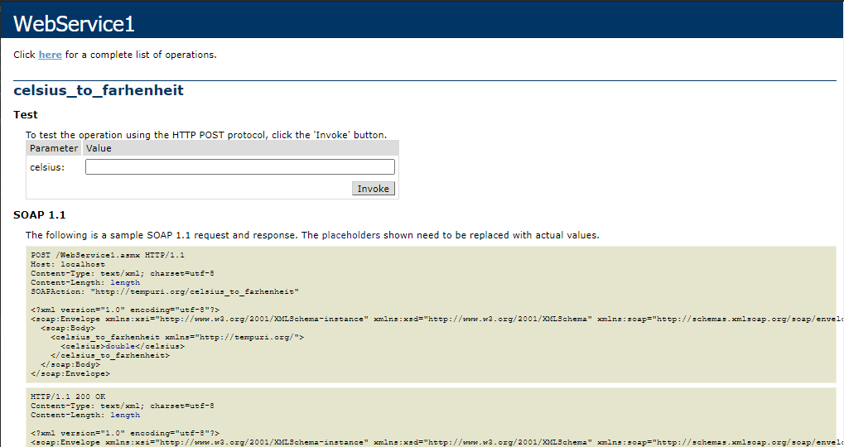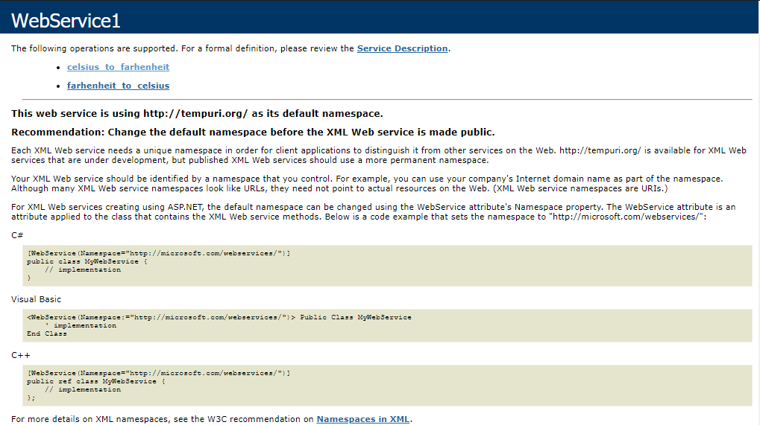

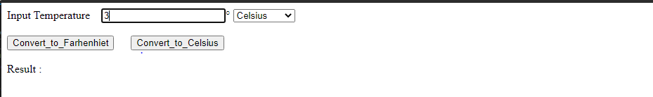

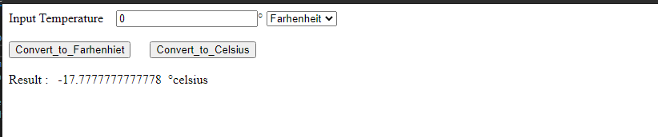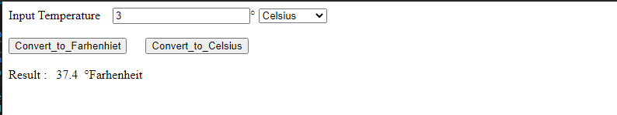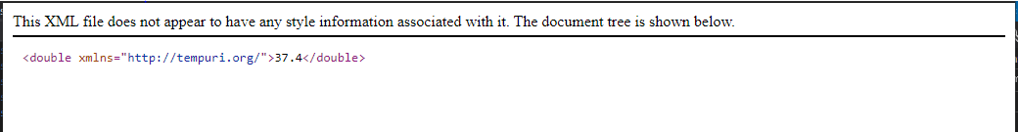

Date: 26/08/2020

**Practical no 2**

**AIM:** Write a program to implement the operation can receive request and will return a response in two ways. a) One - Way operation b) Request –Response

**A)One-Way**

**1. WebForm.aspx file**

|  |
| --- |
| <%@ Page Language="C#" AutoEventWireup="true" CodeBehind="WebForm1.aspx.cs" Inherits="prac2a.WebForm1" %>  <!DOCTYPE html>  <html xmlns="http://www.w3.org/1999/xhtml">  <head runat="server">  <title></title>  </head>  <body>  <form id="form1" runat="server">  <div>  <asp:Button ID="Button1" runat="server" onclick="Button1_Click" Text="Button" />  <br />  <asp:Label ID="lblPagedate" runat="server"> </asp:Label>  <br />  <br />  <asp:Label ID="lblServicedate" runat="server"> </asp:Label>  </div>  </form>  </body>  </html> |

**2. WebForm.aspx.cs file**

|  |
| --- |
| using System;  using System.Collections.Generic;  using System.Linq;  using System.Web;  using System.Web.UI;  using System.Web.UI.WebControls;  namespace prac2a  {  public partial class WebForm1 : System.Web.UI.Page  {  protected void Page_Load(object sender, EventArgs e)  {  }  protected void Button1_Click(object sender, EventArgs e)  {  //Time show before the service is calling  lblPagedate.Text = "on the load time the time is " + DateTime.Now.ToString();  ServiceReference1.Service1Client sc = new ServiceReference1.Service1Client();  sc.OneWayMessage();  //after service is calling that time show  lblServicedate.Text = "After Calling the service the time is " + DateTime.Now.ToString();  }  }  } |

**3. IService.cs:-**

|  |
| --- |
| using System;  using System.Collections.Generic;  using System.Linq;  using System.Runtime.Serialization;  using System.ServiceModel;  using System.ServiceModel.Web;  using System.Text;  namespace prac2a  {  [ServiceContract]  public interface IService1  {  [OperationContract(IsOneWay = true)]  void OneWayMessage();  }  } |

**4. Service1.svc.cs**

|  |
| --- |
| using System;  using System.Collections.Generic;  using System.Linq;  using System.Runtime.Serialization;  using System.ServiceModel;  using System.ServiceModel.Web;  using System.Text;  using System.Threading;  namespace prac2a  {  public class Service1 : IService1  {  public void OneWayMessage()  {  Thread.Sleep(2000);  }  }} |

**Output:-**

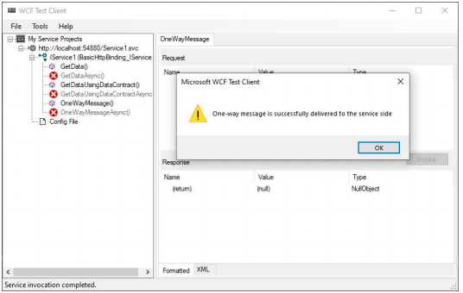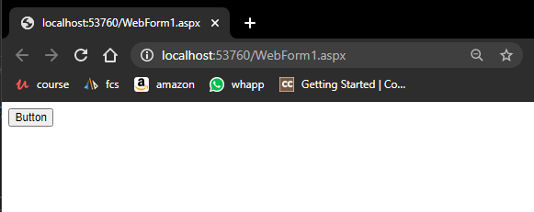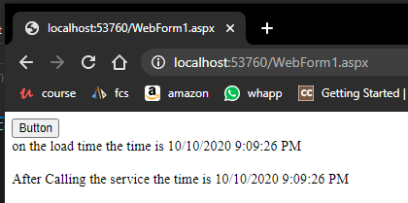

**B) Request –Response**

**1. WebForm.aspx file**

|  |
| --- |
| <%@ Page Language="C#" AutoEventWireup="true" CodeBehind="WebForm1.aspx.cs" Inherits="WcfService2.WebForm1" %>  <!DOCTYPE html>  <html xmlns="http://www.w3.org/1999/xhtml">  <head runat="server">  <title></title>  </head>  <body>  <form id="form1" runat="server">  <div>  <asp:Button ID="Button1" runat="server" onclick="Button1_Click" Text="Button" />  <br />  <asp:Label ID="lblPagedate" runat="server"></asp:Label>  <br />  <br />  <asp:Label ID="lblServicedate" runat="server"></asp:Label>    </div>  </form>  </body>  </html> |

**2. WebForm.aspx.cs file**

|  |
| --- |
| using System;  using System.Collections.Generic;  using System.Linq;  using System.Web;  using System.Web.UI;  using System.Web.UI.WebControls;  namespace WcfService2  {  public partial class WebForm1 : System.Web.UI.Page  {  protected void Page_Load(object sender, EventArgs e)  {  }  protected void Button1_Click(object sender, EventArgs e)  {  lblPagedate.Text = "Page date is " + DateTime.Now.ToString();  ServiceReference1.Service1Client sc = new ServiceReference1.Service1Client();  lblServicedate.Text = sc.RequestReplyPattern();  }  }  } |

**3. IService.cs:-**

|  |
| --- |
| using System;  using System.Collections.Generic;  using System.Linq;  using System.Runtime.Serialization;  using System.ServiceModel;  using System.ServiceModel.Web;  using System.Text;  namespace WcfService2  {  [ServiceContract]  public interface IService1  {  [OperationContract(IsOneWay = false)]  //declare the method which return type is string  string RequestReplyPattern();  }  } |

**4. Service1.svc.cs**

|  |
| --- |
| using System;  using System.Collections.Generic;  using System.Linq;  using System.Runtime.Serialization;  using System.ServiceModel;  using System.ServiceModel.Web;  using System.Text;  using System.Threading;  namespace WcfService2  {  public class Service1 : IService1  {  public string RequestReplyPattern()  {  Thread.Sleep(2000);  return "current time of Service is" + DateTime.Now.ToString();  }  }  } |

**Output:-**

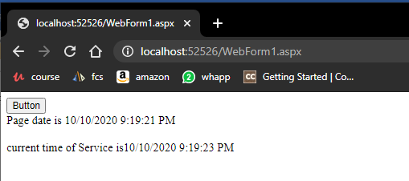

Date: 30/09/2020

**Practical no 3**

**AIM:** Demonstrates using the binding attribute of an endpoint element in WCF with webform.

**Program Code:-**

**IService1.cs**

|  |
| --- |
| using System;  using System.Collections.Generic;  using System.Runtime.Serialization;  using System.ServiceModel;  using System.Text;  namespace WcfService7  {  [ServiceContract]  public interface IService1  {  [OperationContract]  string Recharge(string Name, string company, string number, int amount);  }  } |

**Service1.svc.cs**

|  |
| --- |
| using System;  using System.Collections.Generic;  using System.Runtime.Serialization;  using System.ServiceModel;  using System.Text;  namespace WcfService7  {  public class Service1 : IService1  {  public string Recharge(string Name, string company, string number, int amount)  {  string message = string.Empty;    if (string.IsNullOrEmpty(Name) || string.IsNullOrEmpty(company))  {  message = "Please Enter your name or company name";  }  else  {  if (number.Length == 10 && amount > 0)  {  message = "Recharge of " + amount + " Rs has been done successfully.";  }  else  {  message = "Recharge unsuccessfull. Please try again";  }  }  return message;  }  }  } |

**WebForm.aspx**

|  |
| --- |
| <%@ Page Language="C#" AutoEventWireup="true" CodeBehind="WebForm1.aspx.cs" Inherits="WcfService7.WebForm1" %>  <!DOCTYPE html>  <html xmlns="http://www.w3.org/1999/xhtml">  <head runat="server">  <title>>Mobile Recharge<</title>  <style>  * {  box-sizing: border-box  }  /* Add padding to containers */  .container {  padding: 16px;  }  /* Full-width input fields */  input[type=text], input[type=password] {  width: 100%;  padding: 15px;  margin: 5px 0 22px 0;  display: inline-block;  border: none;  background: #f1f1f1;  }  input[type=text]:focus, input[type=password]:focus {  background-color: #ddd;  outline: none;  }  /* Overwrite default styles of hr */  hr {  border: 1px solid #f1f1f1;  margin-bottom: 25px;  }  /* Set a style for the submit/register button */  .registerbtn {  background-color: #4CAF50;  color: white;  padding: 16px 20px;  margin: 8px 0;  border: none;  cursor: pointer;  width: 100%;  opacity: 0.9;  }  .registerbtn:hover {  opacity: 1;  }  /* Add a blue text color to links */  a {  color: dodgerblue;  }  /* Set a grey background color and center the text of the "sign in" section */  .signin {  background-color: #f1f1f1;  text-align: center;  }  </style>  </head>  <body>  <form id="form1" runat="server">  <div>  <div class="container">  <caption class="auto-style1">  <h1>Recharge</h1>  <hr>  <label for="email"><b>Name</b></label>  <asp:TextBox ID="name" placeholder="Enter full name"  runat="server"></asp:TextBox>  <label for="company"><b>Company</b></label>  <asp:TextBox ID="company" placeholder="Enter full name"  runat="server"></asp:TextBox>  <label for="no"><b>Mobile number</b></label>  <asp:TextBox ID="no" placeholder="Enter full name" runat="server"></asp:TextBox>  <label for="amount"><b>Amount</b></label>  <asp:TextBox ID="amount" placeholder="Enter amount"  runat="server"></asp:TextBox>  <hr>  <asp:Button ID="rechargebtn" runat="server" Text="Recharge" BackColor="#4CAF50"  OnClick="rechargebtn_Click" Height="48px" Width="159px" />  <hr>  <asp:Label ID="lbl" runat="server" Text=""></asp:Label>  </div>  </div>  </form>    </body>  </html> |

**WebForm.aspx.cs**

|  |
| --- |
| using System;  using System.Collections.Generic;  using System.Web;  using System.Web.UI;  using System.Web.UI.WebControls;  namespace WcfService7  {  public partial class WebForm1 : System.Web.UI.Page  {  protected void Page_Load(object sender, EventArgs e)  {  }  protected void rechargebtn_Click(object sender, EventArgs e)  {  try  {  ServiceReference1.Service1Client client = new ServiceReference1.Service1Client();  lbl.Text = client.Recharge(name.Text, company.Text, no.Text,  Convert.ToInt32(amount.Text));  }  catch (Exception)  {  }  }  }  } |

**WebConfig file**

|  |
| --- |
| <bindings>  <basicHttpBinding>  <binding name="BasicHttpBinding_IService1" />  </basicHttpBinding>  </bindings>  <client>  <endpoint address="http://localhost:50600/Service1.svc" binding="basicHttpBinding"  bindingConfiguration="BasicHttpBinding_IService1" contract="ServiceReference1.IService1"  name="BasicHttpBinding_IService1" />  </client> |

**Output:**



